BFSK SIGNAL parameter

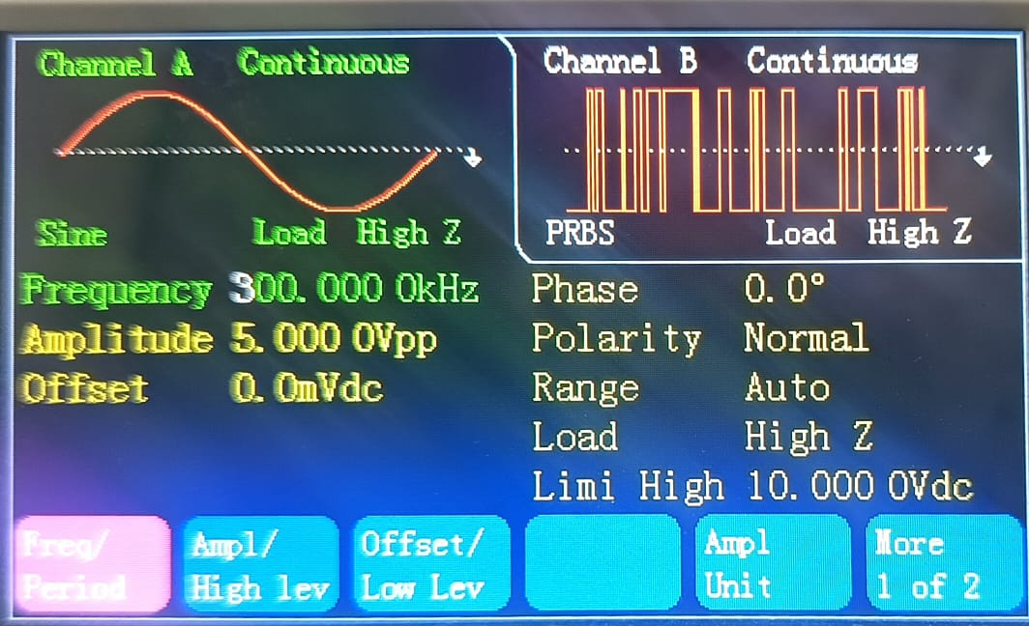

BFSK SIGNAL NOISE PARAMETER

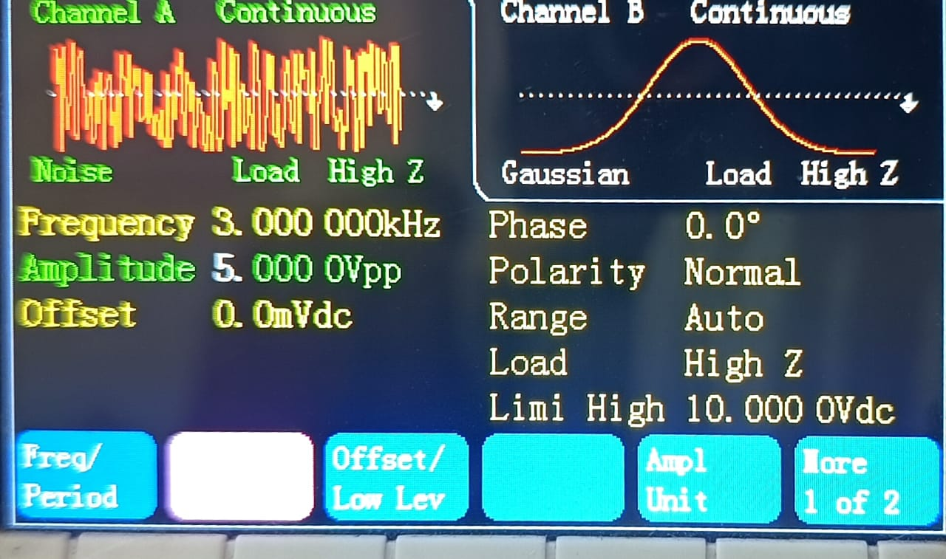

BFSK SIGNAL WITH NOISE

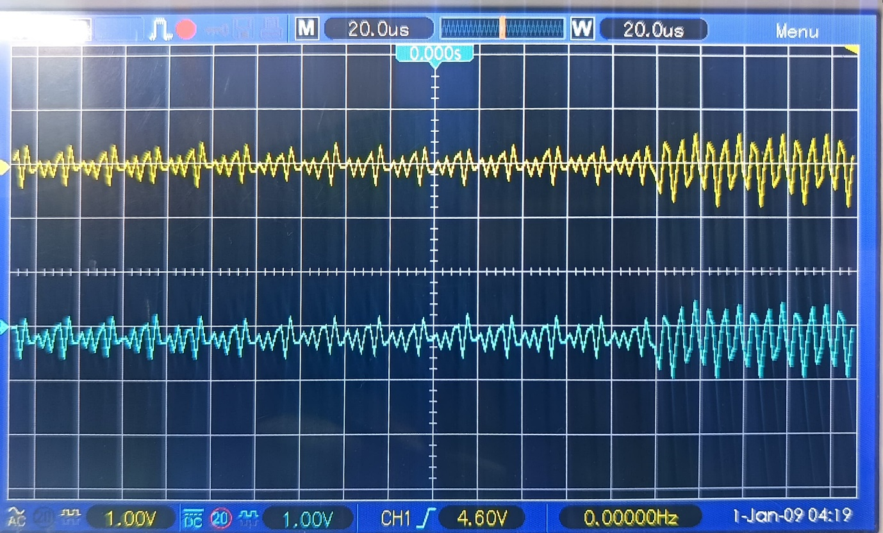

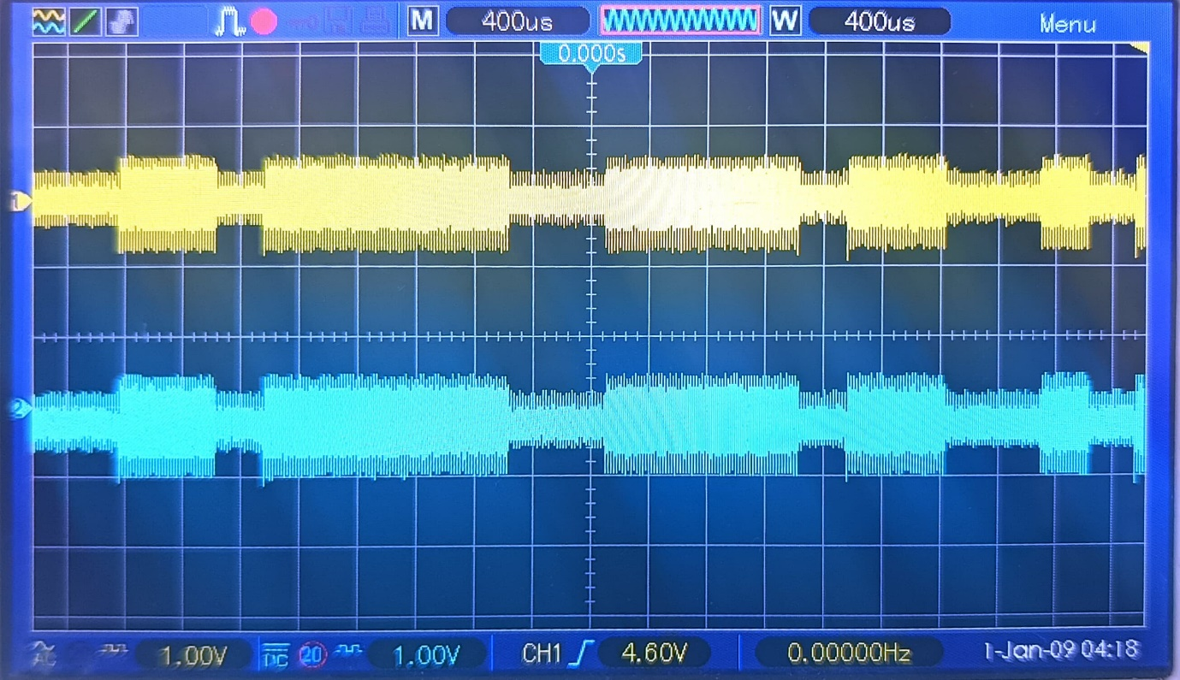

BPSK SIGNAL PARAMETER

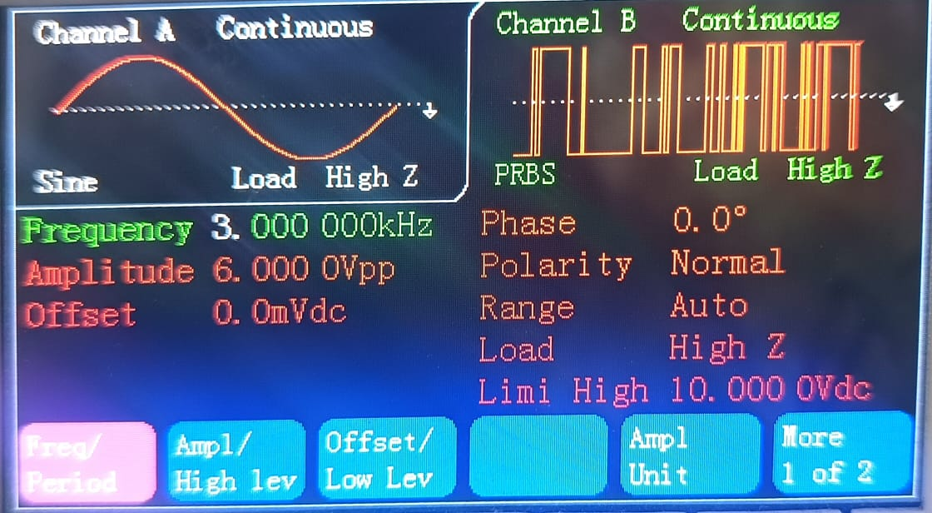

BPSK SIGNAL WITH NOISE PARAMETER

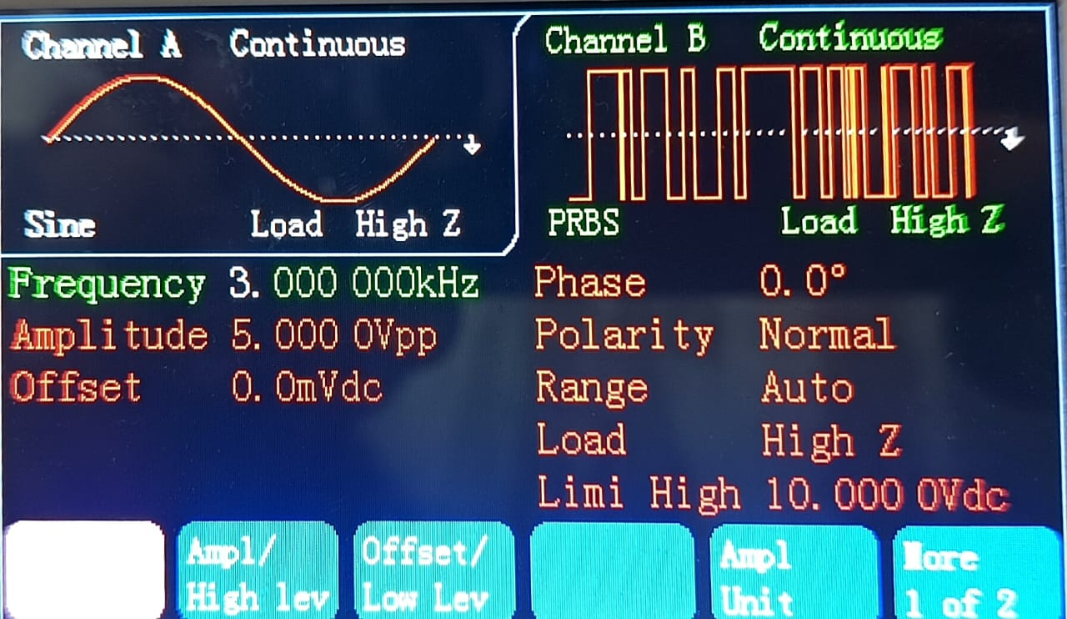

BPSK SIGNAL WITH NOISE

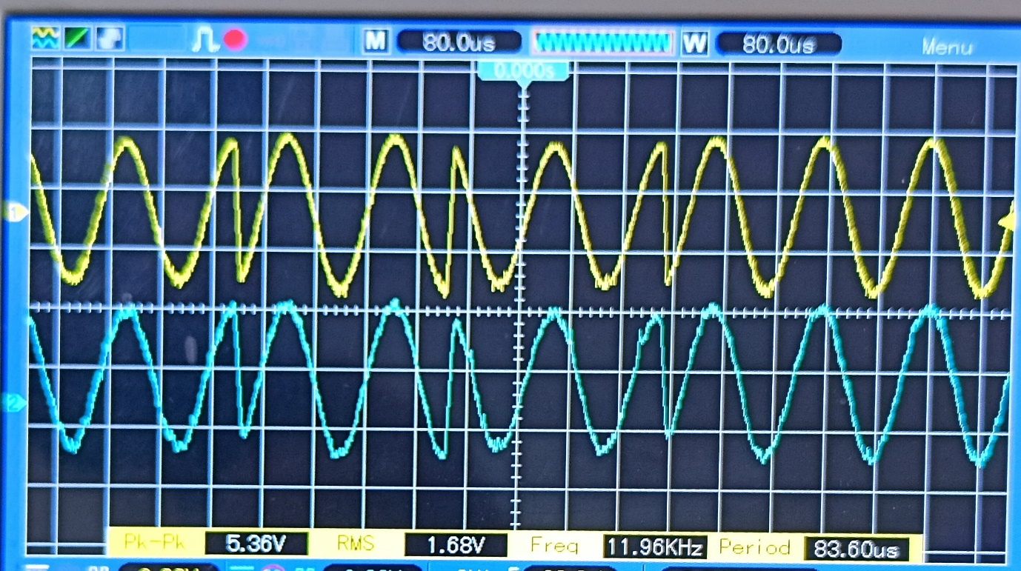

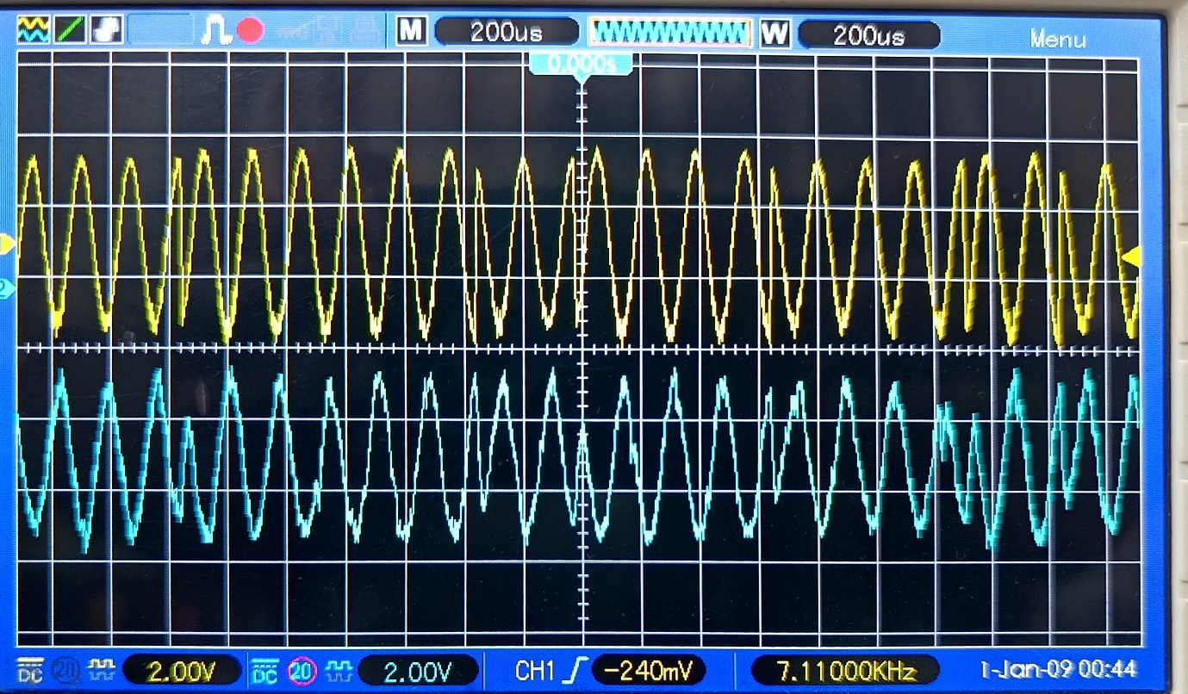

In BFSK

In high frequency the gain reduce because in digital communication the transister acts like a switch that is the reason we got offset problem to fix it we need to replace the transister with opamp.